**Dulux Bunnings ProductRank Script Report**

Table of Contents

Introduction 2

Target Product 2

Duration 2

Proxy 2

Weekly Record 2

Instruction: 3

Step 1: Initiate script 3

Step 2: Set parameters 3

Step 3: Run script 4

Step 4: Audit result 5

Issues 6

Further optimisation 6

# Introduction

This script aims to do product interaction in Bunnings Coveo Search Engine (<https://www.coveo.com/en>) to improve the PageRank in bunnings for target products.

# Target Product

* Dulux 500ml Design Rust Effect Solution
* British Paints Clean And Protect Low Sheen Extra Deep Interior Paint - 4L
* Dulux 1L Interior Paint Wash&Wear Low Sheen Vivid White
* Porter's Paints Eggshell Finish Aniseed 4L

# Duration

20th Sep 2021 – 8th Oct 2021

# Proxy

We are using Smartproxy. Australian residential proxies in Smartproxy should begin from port 30001. Each port has thousands of residential IP addresses and more, but will rotate proxies for every connection. So in order to make sure we use a new IP address to visit the product every time, we will change port every time.

# Weekly Record

|  |  |  |  |  |  |
| --- | --- | --- | --- | --- | --- |
|  |  | **Dulux 500ml Design Rust Effect Solution** | **British Paints Clean And Protect Low Sheen Extra Deep Interior Paint - 4L** | **Dulux 1L Interior Paint Wash&Wear Low Sheen Vivid White** | **Porter's Paints Eggshell Finish Aniseed 4L** |
| **20/09/2021-26/09/2021** | Start rank | Rust Paint - Page 2, Rank 5 | Wall Paint - Page 4, Rank 33 | Wall Paint - Page 3, Rank 20 | Wall Paint - Page 6, Rank 9 |
| End rank | Rust Paint - Page 2, Rank 5 | Wall Paint - Page 4, Rank 34 | Wall Paint - Page 3, Rank 20 | Wall Paint - Page 5, Rank 35 |
| **27/09/2021-03/10/2021** | Start rank | Rust Paint - Page 2, Rank 5 | Wall Paint - Page 4, Rank 33 | Wall Paint - Page 3, Rank 20 | Wall Paint - Page 6, Rank 10 |
| End rank | Rust Paint - Page 1, Rank 4 | Wall Paint - Page 1, Rank 12 | Wall Paint - Page 1, Rank 15 | Wall Paint - Page 1, Rank 16 |
| **04/10/2021-08/10/2021** | Start rank | Rust Paint - Page 1, Rank 4 | Wall Paint - Page 1, Rank 8 | Wall Paint - Page 1, Rank 13 | Wall Paint - Page 1, Rank 15 |
| End rank | Rust Paint - Page 1, Rank 4 | Wall Paint - Page 1, Rank 3 | Wall Paint - Page 1, Rank 5 | Wall Paint - Page 1, Rank 8 |

# Instruction:

## Step 1: Initiate script

Please put **extension.py library** (which used to connect with Smartproxy) and **product_interact.ipynb** script code in the same folder, install all libraries listed at the top of the script, then use **Anaconda** – **Notebook** – go to the folder – open **product_interact.ipynb** script.

## Step 2: Set parameters

**USERNAME** regards to Smartproxy username, last used is"sp47257626".

**PASSWORD** regards to Smartproxy username password, last used is "spsrawroao".

**ENDPOINT** should be "au.smartproxy.com", we are using Smartproxy.

**PORT_FIRST** regards to the start port, should be bigger than 30001 when using Smartproxy.

**PORT_INTERVAL** is the number of ports used in the same time in threading, recommend to use 2 ports at the same time.

**PORT_NUM** is the total number of ports, should be divisible by PORT_INTERVAL (PORT_NUM/PORT_INTERVAL=0).

**URL** is where you want the script to run. Currently the script supports bunnings website (“https://www.bunnings.com.au/") and Dulux product website (like "https://www.dulux.com.au//specifier/products/730”).

**PRODUCTS** is the list of products to be searched in bunnings website, format should be like [

[search keyword 1, product 1 name, page number of product 1],

[search keyword 2, product 2 name, page number of product 2],

…

]

**PURCHASE_METHODS** is bunnings product purchase method list, see Screenshot 1. Usually choose common purchase methods for all listed products.

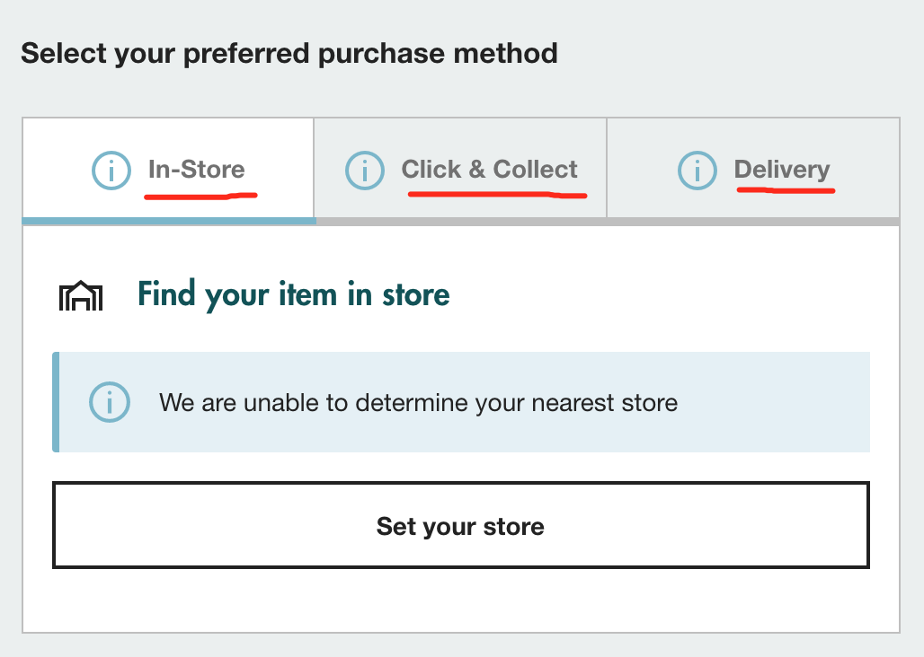

Screenshot 1

**INFO_TABS** is bunnings product information tabs, see Screenshot 2. Usually choose common information tabs for all listed products.

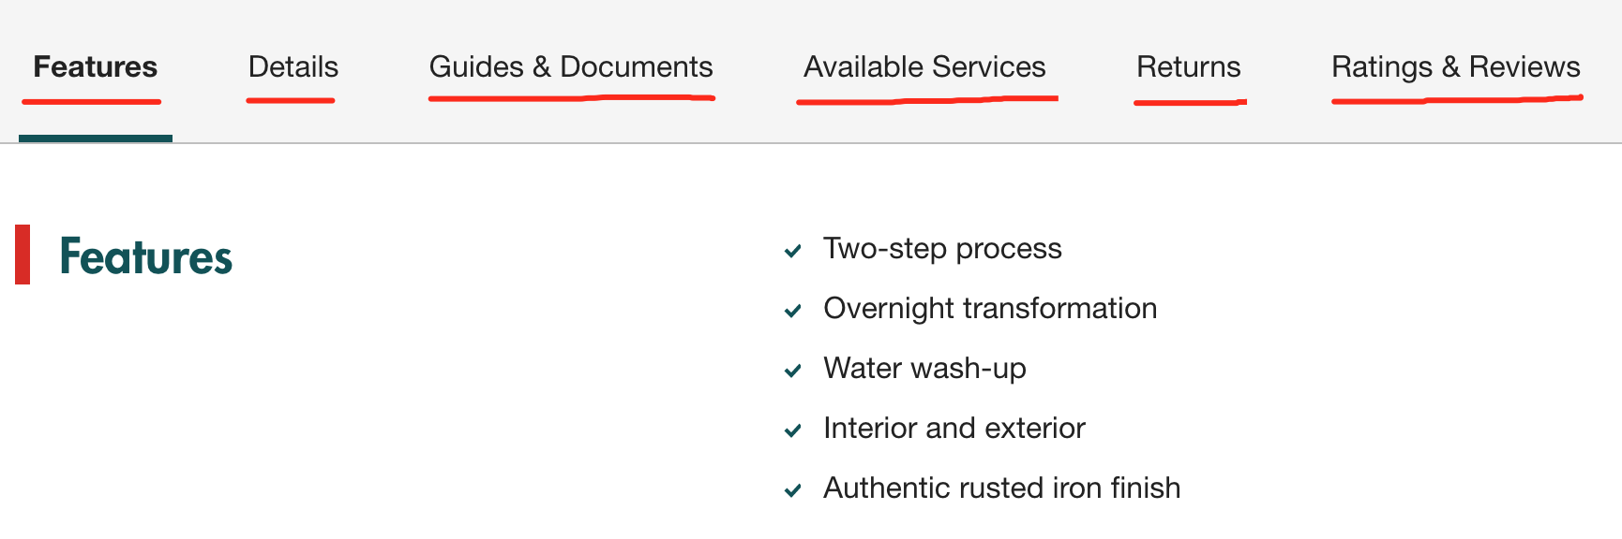

Screenshot 2

**BREADCRUMBS** is bunnings product breadcrumb list, see Screenshot 3. Usually choose common breadcrumbs for all listed products.

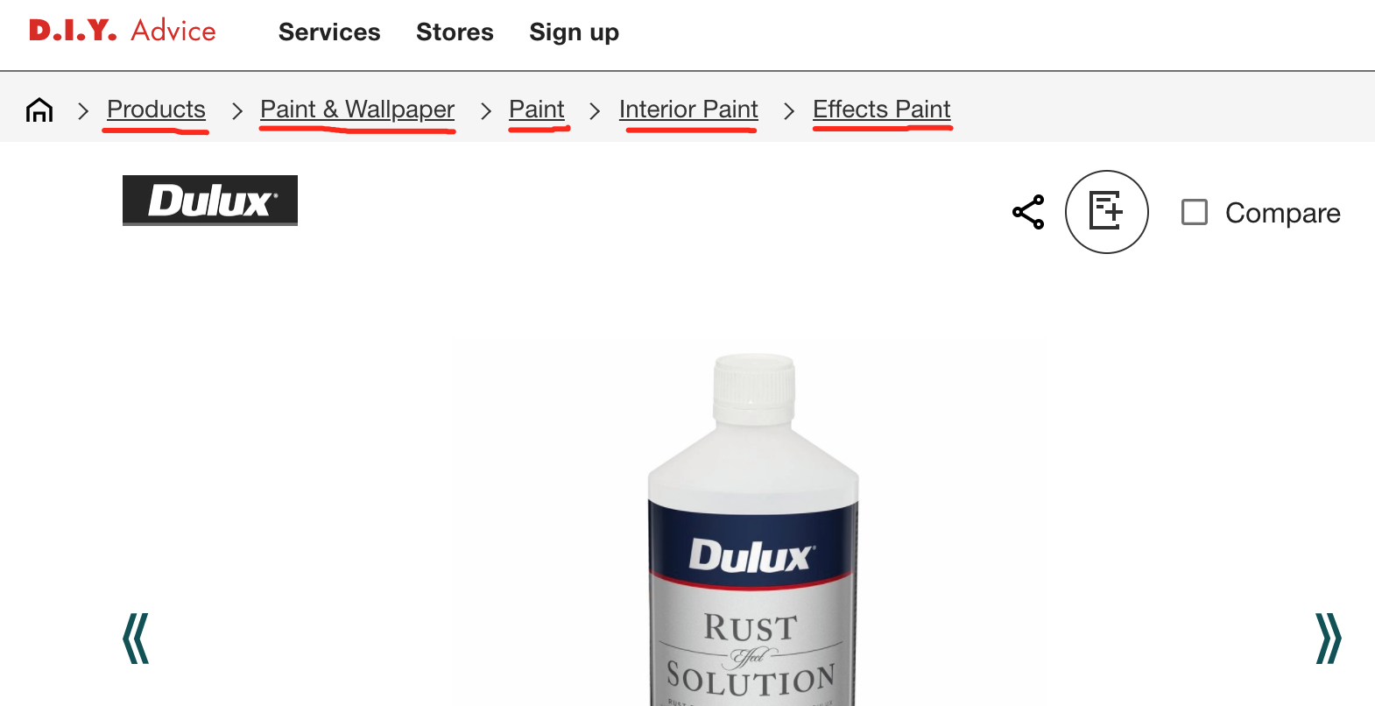

Screenshot 3

## Step 3: Run script

Simply click **Run** or click **Kernel** - **Restart & Run all** to run the script, it will automatically open 2 or more (the number you set in **PORT_INTERVAL**) Google Chromes at the same time, and go through all steps in the script.

For example, if you set 2 products in the **PRODUCTS** list, **PORT_FIRST = 30001, PORT_INTERVAL = 2**, **PORT_NUM = 10**, the script will fist use port 30001 and 30002 to visit and interact with product 1 and product 2, then use port 30003 and 30004 to visit and interact with product 1 and product 2… at last use 30009 and 30010 to visit and interact with product 1 and product 2.

## Step 4: Audit result

The result will automatically generated underneath the cell after each task completed. For example, the result will show as following:

Port 30001 with product "Dulux 500ml Design Rust Effect Solution" task starts at Mon Oct 18 14:13:48 2021

Port 30001 opens browser successfully!

Port 30001 input keyword in the search engine successfully!

Port 30001 goes to page 1 successfully!

Port 30001 finds product: "Dulux 500ml Design Rust Effect Solution" successfully!

Port 30001 clicks "Click & Collect" tab successfully!

Port 30001 clicks "Delivery" tab successfully!

Port 30001 clicks "Details" tab successfully!

Port 30001 clicks "Returns" tab successfully!

Port 30001 clicks "Ratings & Reviews" tab successfully!

Port 30001 goes to "Interior Paint" page successfully!

Port 30001 goes back to the product page successfully!

Port 30001 goes to "Paint" page successfully!

Port 30001 goes back to the product page successfully!

Port 30001 goes to "Products" page successfully!

Port 30001 goes back to the product page successfully!

Port 30001 goes to Home page successfully!

If all tasks complete successfully, it will show:

Port 30001 with product "Dulux 500ml Design Rust Effect Solution" task Completed at Mon Oct 18 14:17:18 2021

If any of tasks complete unsuccessfully, it will show:

Port 30001 with product "Dulux 500ml Design Rust Effect Solution" task failed at Mon Oct 18 14:17:18 2021

Usually we will treat the port successfully visit the specific product if it shows “task completed”. But sometimes we will also treat it successfully if it shows “task failed” but successfully complete two or more breadcrumbs visits, which means it will have session duration.

The result output could be optimised by export summary document after add retry function, in order to reduce the task failed risk caused by unpredictable issue. (see Further optimisation)

# Issues

Couple of issues may be faced when running the script:

1. Treading failed, leading to all tasks belong to this treading failed, should check and retry the treading.
2. Temporally proxy issue, leading to connection failed, should check and retry the task.
3. Network issue, leading to long response time and task failed, should check and retry the task.
4. Long loading time issue, leading to task failed, should check and retry the task.

# Further optimisation

1. Add retry function to retry the task if it failed caused by some unpredictable issues, like proxy issue, network issue or long loading time issue.
2. Add checking page number function to avoid manually updating the product page number if it changes every time.